**TELSTRA NEWS FEED APPLICATION**

**(ANDROID) INFORMATION DOCUMENT V0.1**

**Prepared By:**

**Infosys Ltd**

**CHANGE HISTORY**

|  |  |  |  |
| --- | --- | --- | --- |
| **Version** | **Date** | **Revised By** | **Description(s) of Change** |
|  |  |  |  |
|  |  |  |  |
| 0.1 | 21/01/2015 | Sanjay J | Initial Draft |
|  |  |  |  |
|  |  |  |  |
|  |  |  |  |
|  |  |  |  |
|  |  |  |  |
|  |  |  |  |
|  |  |  |  |
|  |  |  |  |
|  |  |  |  |
|  |  |  |  |
|  |  |  |  |

**REFERENCE DOCUMENTS**

|  |  |  |
| --- | --- | --- |
| **Document** | **Document Name** | **Version** |
|  |  |  |
|  |  |  |
| Client PDF document | Androidproficiencyexercisev2.0.pdf | 2.0 |
|  |  |  |
|  |  |  |
|  |  |  |

**Table of Contents**

**1. REQUIREMEN****T** **4**

**2. LOGICAL VIE****W** **5**

**3. SCREEN****S** **6**

**4. TEST CASE EXECUTIO****N**--------------------------------------------------------------------------------**10**

**5. OPEN SOURCE CODE / THIRD PARTY LIBRAR****Y**  **1****1**

**1. Requirement**

Telstra provided a requirement document for POC at high level and following are the requirements implemented in the POC code.

Note: Some of the requirement (technical) internally added to complete the use case.

|  |  |
| --- | --- |
| **No** | **Requirement** |
|  |  |
| 1 | Application should show news feed screen when user click on the application launcher icon. |
|  | Progress dialog should be visible until initial data download from the back end system. |
|  |  |
| 2 | Application should show error in case network is not available. |
|  |  |
| 3 | Application should show error in case backend system is down or corrupted data comes |
|  | from the backend. |
|  |  |
| 4 | Application should show all news / rss feeds from the back end as soon as data available |
|  | on the device. |
|  |  |
| 5 | Image should be downloaded in the Lazy format. Rendering should not wait for all the |
|  | images to be downloaded |
|  |  |
| 6 | Application should show default image in case image is not available at backend or url is |
|  | not available |
|  |  |
| 7 | Application should refresh content while user clicks on refresh button from menu. |
|  |  |
| 8 | When refresh is clicked, if network is not available application should show appropriate |
|  | message |
|  |  |
| 9 | While refresh is clicked , if back end system not available application should show |
|  | appropriate message |
|  |  |
| 10 | Click on the back button should show application exit confirmation message. On click of |
|  | the yes button should exit the application. On click of the No button application should |
|  | run in the same stage from where user click back button. |
| 11 | All content should be vertically scrollable |
|  |  |
| 12 | Title should be updatable from JSON file |
|  |  |
| 13 | Each row should dynamically change height dent on the content from JSON file |
|  |  |

**2. Logical View**

Following table describe short description of each class used in the application.

|  |  |  |
| --- | --- | --- |
| **Class name** | **Description** |  |
|  |  | |
| NewsFeedScreenActivity  INetworkListener | These classes are used to handle the client and backend system, Used to check the network connectivity and initiates the download of data. | |
|  |  | |
| DownloadTask | This class downloads the data by making http calls and feeds the data to the JSON parser | |
|  |  | |
|  |  | |
| NewsfeedData | This class hold the news feed data for the application. | |
| JSON Parser | This class handle json string parsing in the application. It parse Json | |
|  | screen and return proper structure data to calling module | |
|  |  | |
| Lazy Adapter, Memory Cache, FileCache,ImageLoader,Util | These classes are used to load all images in a Lazy loading method. | |
|  | loads all images in the background and render on the screen once available | |
|  | from backend |  |
|  |  | |
|  | This are UI element on the screen. This will be the visible content on the | |
| News Feed Screen, | screen. |  |
| Refresh |  |  |
| Button,  Progress dialog |  |  |
|  |  | |
|  | | |

**3. Screens**

**Main News Screen**

****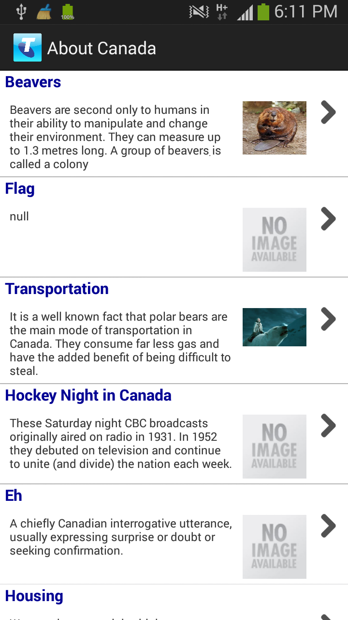

**Refresh Screen**

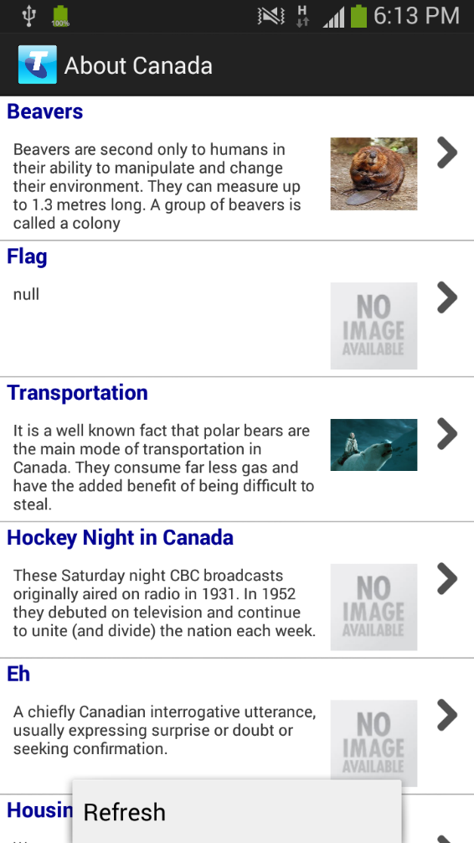 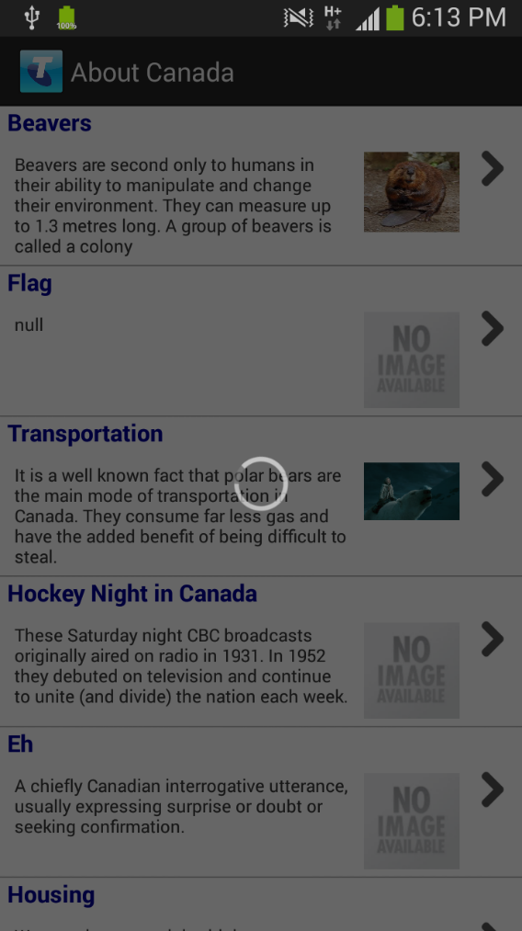

**No Network Message**

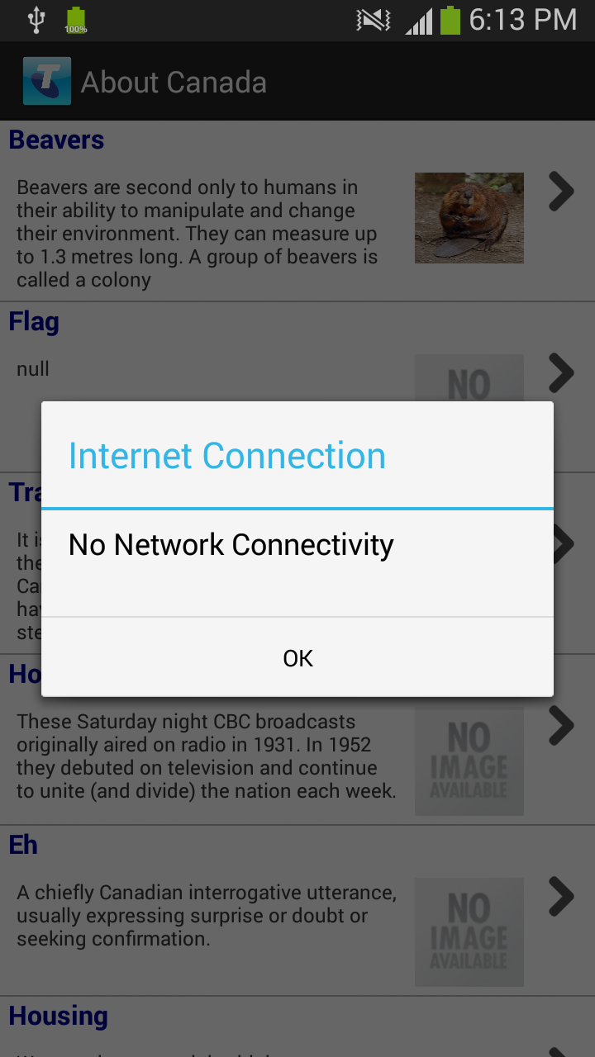

**Exit Confirmation Message**

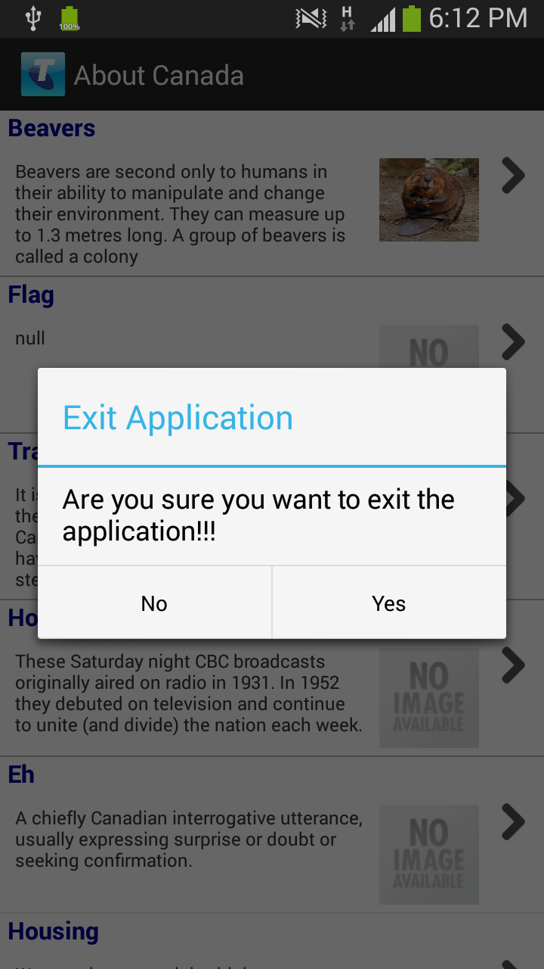

**4. Test Case Execution**

|  |  |  |
| --- | --- | --- |
| **No** | **Test Case** | **Result** |
|  |  |  |
| 1 | Application should show proper error message if network is not available | Pass |
|  |  |  |
| 2 | Application should show proper error message in case back end server is not | Pass |
|  | accessible or JSON data is corrupted |  |
|  |  |  |
| 3 | Application should show News Feed Screen once data download completed | Pass |
|  |  |  |
| 4 | Application should load images in the Lazy loading format. It should show all data | Pass |
|  | first and images should be loaded in the background |  |
|  |  |  |
| 5 | Application should show dummy images in case of Wrong URL or image | Pass |
|  | downloading error |  |
|  |  |  |
| 6 | Application should do Refresh functionality on click of refresh button | Pass |
|  |  |  |
| 7 | Application should show proper error message in case no network while | Pass |
|  | Refresh button is clicked |  |
|  |  |  |
| 8 | Application should show proper error message in case backend system not | Pass |
|  | accessible or some issue while parsing JSON while executing Pull to refresh |  |
|  |  |  |
| 9 | Application should resize each row depend on the content of the JSON file | Pass |
|  |  |  |
| 10 | Application should update Title bar from the backend JSON data | Pass |
|  |  |  |
| 11 | Application should show exit confirmation message on back click press. | Pass |
|  |  |  |
| 12 | Application should exit if user press Yes on exit confirmation message popup | Pass |
|  |  |  |
| 13 | Application should remain in the same state if user click No on Exit confirmation | Pass |
|  | message |  |
|  |  |  |

**5. Open source code / third party library**

|  |  |
| --- | --- |
| Lazy Loading | Used open source code to complete this functionality |
|  | Code contain downloading of image, maintaining queue, memory cache |
|  | management part |
|  | Following is the link |
|  | http://www.androidhive.info/2012/02/android-custom-listview-with-image- |
|  |  |